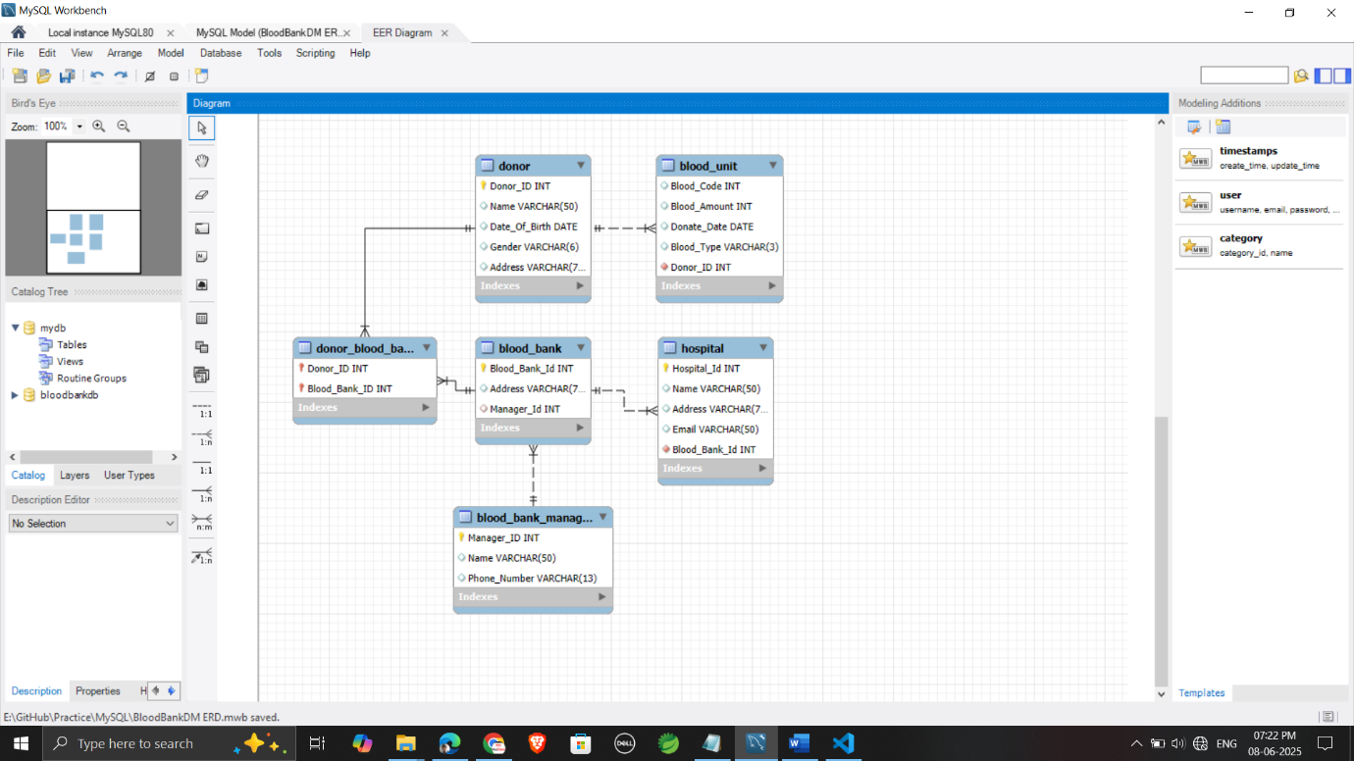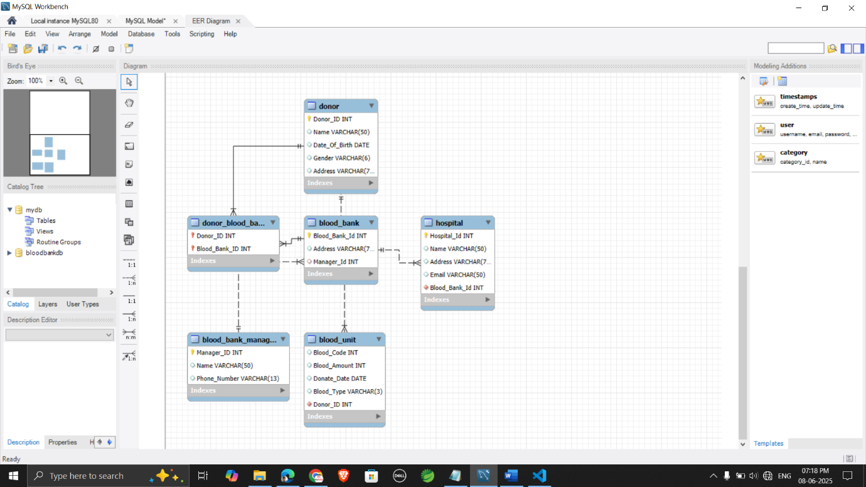

Blood_Bank_Manager
Hospital
Blood_Bank
Donor_Blood_Bank
Blood_Unit
Donor

